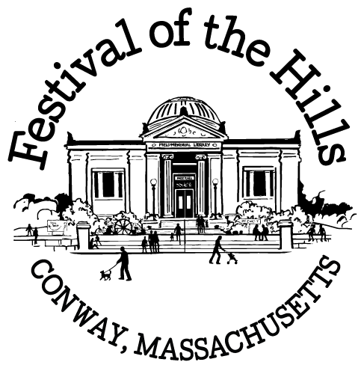

Hello Conway Artist,

You are cordially invited to participate in the annual art exhibit held at the Conway Festival of the Hills. All artists who reside in or have a studio in Conway are invited to show one or more artworks in this wonderful event that draws hundreds of visitors. Whether you are an established professional or an artist who has created a few pieces, we hope to include your artwork in the show!

For those of you who are new to the exhibit, here's how it works:

The Field Memorial Library will be transformed into a gallery space as a beautiful backdrop for your artwork. We will have wall space for hanging pieces, a glass case for jewelry and other small works, and tables for ceramics, sculpture, basketry, woodworking, or other displays.

The artwork will be installed on Saturday, October 3rd, so your work needs to be in the library by the end of that morning.
1. Please read the details on the next page.

2. Fill out the form (pages 3 & 4) and mail or email it back to me.
(Details for returning the form via email can be found at the end of the form)

3. Deliver and pick up your work, and pitch in on the weekend of the festival!
The second page of the form is a call for volunteers. This is your show—we need your
help to carry it off in style!

If you have any questions, please contact me at conwayfestivalarts@gmail.com.

We look forward to seeing you and your artwork at the festival!

Thanks!

Aimee Anderson, Festival Art Show Coordinator
P.O. Box 45
Conway, MA 01341
conwayfestivalarts@gmail.com
EXHIBIT DETAILS
Installation

- Work that will hang on the wall needs to be READY TO HANG. Each piece must have screw eyes or picture wire on the back that will support its weight. Regretfully, work that is not ready to hang will not be included in the show.

- If you are arranging work on a table, bring props as needed (easel, cloth, other) to effectively display your work.

- If your work needs a sculpture stand, you will need to provide your own; table space is limited, and not suitable for larger 3-D work.

- You can arrange your own pieces, or we will be happy to install them for you.

Labels & Artist Info

Please do not attach business cards or labels to the artwork. We will provide standard labels for each piece.

This is an exhibit, not a sales gallery, so the library requests that we do not put prices on the works.

You are encouraged to bring business cards, a binder with pictures of additional works, a resume or biography, or an artist's statement, articles or reviews, etc., which can be left at the librarian's desk. Visitors enjoy looking through these materials to find out more about the artists.

Drop Off & Pickup

Work can be dropped off at the library on Thursday night, Oct. 1st, from 6:30 p.m. to 8 p.m., or on Saturday morning, October 3rd, from 10:00 a.m. to noon. Please do not bring work to the library outside these hours— no one will be available to accept it! If you can’t deliver at these times, alternative arrangements can be made (see form).

To be included in the show, work needs to be in the library by noon on Saturday. Work delivered later will be regretfully declined!

All work must be removed from the library between 4 and 5:00 p.m. on Sunday. If you can't pick up your work after the festival, we will store it at a volunteer's house, and you can arrange to get it back during the following week.

Security & Insurance

Volunteers (one of whom may be you!) will be in attendance during the exhibit to keep an eye on things and answer questions.

Neither the Festival Committee nor the Field Memorial Library carries insurance on exhibited artwork. Exhibit at your own risk, but rest assured that we have a very good security record. The library will be locked outside of exhibition hours and attended throughout exhibition hours by volunteer gallery sitters
CONWAY FESTIVAL OF THE HILLS ART EXHIBIT – EXHIBITOR’S FORM
Field Memorial Library, October 4, 2026

Name:

Address:

Phone:

Email (optional):

You do not need to tell us exactly which pieces you plan to show—you can decide that in the meantime. For planning purposes, we just need to know how many pieces you would like to include, and how the work will be displayed. Space is limited, so depending on the dimensions, there may be room for 2 large, or 4-5 small works.

Number of works to be displayed in each manner:
Hanging Display case Small table Freestanding
I will bring my own sculpture stand(s)

Description/comments:

How will you get the work to the exhibit?

I will bring it to the library on Thursday evening or
Saturday morning.
I am not able to drop off my work. Please contact me to make
alternative arrangements.

How will you collect your work after the exhibit?

I will pick it up at the library on Sunday between 4 and 5 p.m.
I will pick it up at volunteer's house as soon as possible after Sunday.
Security

I acknowledge that work exhibited will not be insured, but the Festival
Committee volunteers will do their best to handle work with care and to
monitor the gallery during the festival.
(form continues, next page)
We really, really NEED your help!
Can you volunteer for any of the following jobs?

Help move the heavy library furniture out of the way
Thursday, October 1, 2026, 6:30-7:30 p.m.
Help hang the canvas draping in the library
Thursday, October 1, 2026, 7:00-8:00 p.m.

Help install the show on Saturday, October 3, 2026.
12 noon to 2 pm
2pm to 4 pm

Sit for 1 hour with the library exhibit on Sunday, October 4, 2026.
(We will schedule time slots when you deliver your work.)

Help take down the show on Sunday at 4 p.m.

Help move the heavy library furniture back into place on Sunday at
4:30 p.m.

Sorry, I'll be unavailable to help but I'd still like to participate in the
Exhibit. I'll do my best to help out next year!

Spread the word…
Do you know a Conway artist who you think would like to receive this information? Send them to www.festivalofthehills.com, or send me names and contact info (mailing address, phone number or e-mail address) and I'll send them a form.

Please return this form to:

Aimee Anderson
Festival Art Show Coordinator
P.O. Box 45
Conway, MA 01341
conwayfestivalarts@gmail.com

Thank You!

